# Send Command via CW Control

Author - Chuck Fowler

Created - 05/2021

Version - .1

Purpose

Send Control / ScreenConnect send Shell or Powershell commands to Windows, Linux, or Mac computers. (Even if the Automate Agent is offline).

The script can be used as a standalone or function script.

Properties

CWC_ScriptComputerID – Enter the Target ComputerID of the computer sending PowerShell to Control Server.

“Send Command via CW Control – Set ComputerID” script has been created to simplify this process.

Parameters – (When run as standalone)

Control Command– Enter the Shell or PowerShell command to be executed via Control

Run as PowerShell– (True,False) – Results are saved in the Script Logs

Prerequisites

1. Property ‘CWC_ScriptComputerID’ assigning ComputerID of the computer sending Commands to Control. The “###.HOSTEDRMM.COM” Automate servers do not have an agent installed and are locked down from running LTSERVER Commands. If a computer is not checking into Automate, of course if cannot be the one responsible for sending the commands to Control. The assigned computer will be responsible for sending and receiving all commands with the Control Server.
2. The Control Plugin must have all of the fields entered and working status (see image).

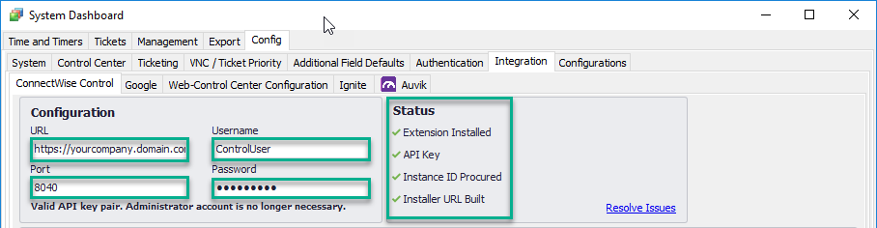

Due to security settings, this script will not work if your connected to the Demo ScreenConnect Servers.

## Function Inputs

@Command@ - Shell or Powershell (supports multi-line entries)

@PowerShell@ - [True or False] – Is the command PowerShell?

## Function Outputs

@CommandResults@ - Results from the @Command@

@ControlAgentStatus@ - [Online or Offline] – If the computer is online and connected to Control.

@ControlHostStatus@ - [Online or Offline] – If the target ComputerID is online. (See Prerequisite #1)